User Manual of
District GIS Parakh — Sudden Inspection
For Onboarded Departments
(Prepared by MPSeDC GIS Department)
Madhya Pradesh State Electronics Development Center (MPS@DC)
State IT Center, 47-A, Arera Hills, Bhopal, M.P. – 462011
Phone: +91-755-2518300, Fax: +91-755-2579824

Document Information
Property | Value
Document Title | District GIS Parakh Sudden Inspection - Comprehensive User Manual
Project Name | District GIS Parakh
Developed by | MPSeDC (Madhya Pradesh State e-Governance Data Center)
Document Version | 1.2
Date of Issue | 20-August-2026 (originally issued 4-Dec-2025)
Status | Released — Updated
Classification | Internal Distribution

Revision History
Version | Date | Author | Summary of Change
1.0 | 04-Dec-2025 | MPSeDC GIS Dept. | Initial release — mobile app login, location permission, Navigate-to-Point-of-Interest, map/route, buffer-range filter, and route-start flow (Steps 4.1.1–4.1.9).
1.1 | 09-Jun-2026 | MPSeDC GIS Dept. | Change Request logged: form should auto-open on map click (matching Asset Mapping behaviour); offline-mode support requested as an enhancement.
1.2 | 20-Aug-2026 | Dheeraj Motiyani | Added the full Sudden Inspection form-fill screens (Entity Type, Site Name, Address, Observations, 6-photo capture, video recording), the Save-as-Draft and Submitted-Forms confirmation screens, the New Modules access screen, and a new Web Portal — Sudden Inspection Report section (Section 5). Clarified current offline-mode limitation (see Section 4.1.5 note).

Document Approval
Role | Name | Designation | Signature
GIS Head | Rakesh Dubey (Sir) | GIS Head, MPSeDC
Project Manager | Ajeet Pal Singh | Data Specialist/PM, MPSeDC
Senior BA
Date

District GIS Parakh Introduction
- Data Collection Form
- General Department Form
- General Form for citizen users
- Inspection Form
- Questionnaire Form
- Survey Form
- Citizen Users
- Department Users
- Agency Users

4. District GIS Parakh Sudden Inspection (Mobile App Flow)

4.1 How department users log in to the mobile application

4.1.1: Installation
- Open the Google Play Store on your mobile device.
- Search for the "Parakh" application or click this link: https://play.google.com/store/apps/details?id=com.mpssdi.parakh
- Tap on the application and select "Install".
- Wait for the installation process to complete.

4.1.2: Opening the application
- On your device's home screen or in the application drawer, locate the "District GIS Parakh" application icon.
- Tap the icon to open the application.

4.1.3: Providing location permission
- When you open the application for the first time, a prompt may appear asking for permission to access your device's current location.
- Click "Allow" or "Grant permission" to allow the application to access your current location.

4.1.4: Select Navigate to point of interest on Map & Route
- At Home Page of District GIS Parakh App will show "Navigate to point of Interest".
- Click and Open this option and Map will open.

4.1.5: Functionality to do Sudden Inspection
- Once User opens Map, User can perform Inspection of the Asset.
- On clicking the map, the form should open automatically — similar to the Asset Mapping functionality, where clicking on the map opens the asset form.
NOTE: Sudden Inspection does NOT currently open in Offline Mode. Active internet/data connectivity is required to launch and complete this module, unlike Site Inspection and Asset Survey, which support Save-as-Draft under poor connectivity. Offline support for Sudden Inspection was raised as a Change Request on 09-Jun-2026 and remains an open enhancement — this manual will be updated again once it is delivered.

4.1.6: Search Destination location to Route through the Map
- Destination location route path will open on the Map.
- Then Select filter option on Top Right below destination location.

4.1.7: Destination location to Route through the Map
- This Select Filter Option will open below screen and proceed with below options:
- First choose Asset Projects (Running Projects and Other Projects) to be surveyed.
- Second, select the Buffer Range (kilometre) while routing through the Map path.
- Sudden Inspection needs to be done for all Projects that fall within that buffer range while routing through the Map path.

4.1.8: Map Route and Projects are Visible for Sudden Inspection
- Source and Destination route path is visible on the map; below it, Projects are visible for which Sudden Inspection can be conducted by the Department, following the selected buffer range.
- Basic details of each project are shown below the map.
- "Start Inspection" route follows the destination location, covering all projects within the buffer-range kilometre.

4.1.9: Home Screen — Accessing Sudden Inspection via New Modules
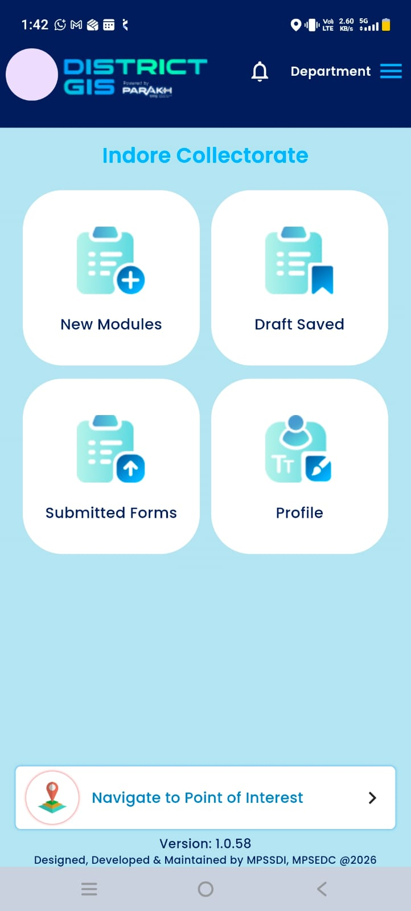
Screen — Home dashboard (example: Indore Collectorate), showing New Modules, Draft Saved, Submitted Forms, and Profile tiles.

4.1.10: Selecting Sudden Inspection from New Modules
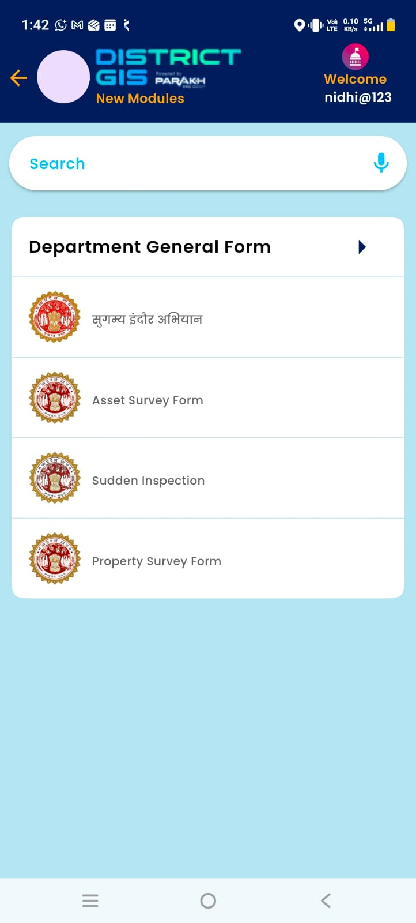
Screen — New Modules list, including सुगम्य इंदौर अभियान, Asset Survey Form, Sudden Inspection, and Property Survey Form.

4.1.11: Filling the Sudden Inspection Form — Part 1 (Site Details)
- Entity Type (mandatory) — e.g. Park, Anganwadi, Health Care.
- Inspection Site Name (mandatory).
- Address — auto-suggested/enterable text (e.g. plus-code style address with locality, district, state, and PIN).
- Observations — free-text field with a voice-input (microphone) option for faster field entry.
- Capture Photo — Add Photo 1 (mandatory) onward, each with an "Open Camera" action; a thumbnail with "Tap to open" appears once captured.
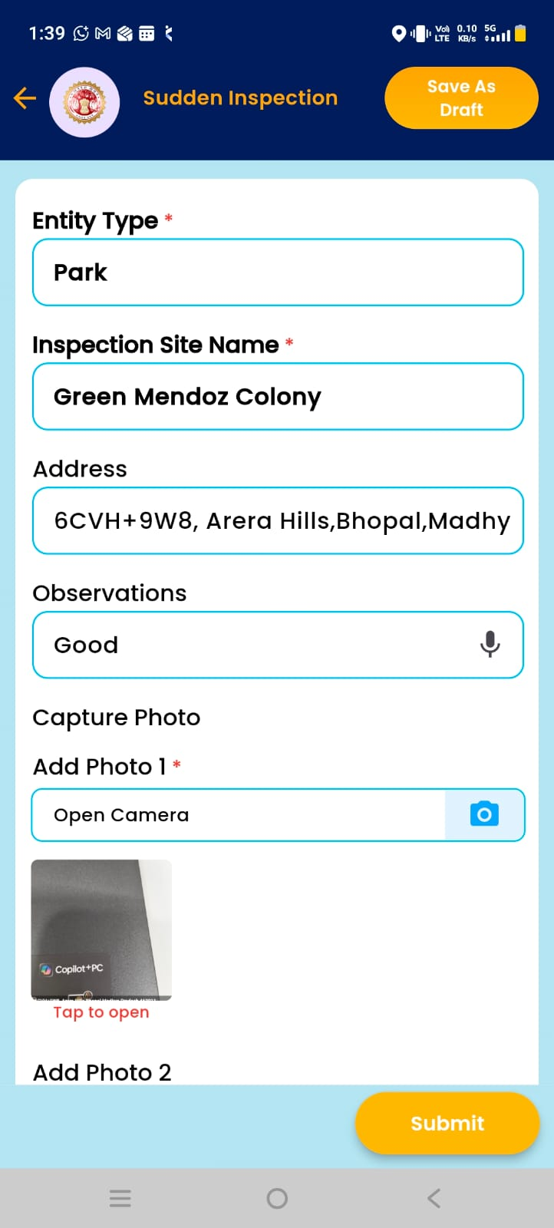
Screen — Sudden Inspection form: Entity Type, Inspection Site Name, Address, Observations, and Photo capture (top section).

4.1.12: Filling the Sudden Inspection Form — Part 2 (Additional Photos, Video & Submit)
- Add Photo 3 – Add Photo 6 — each with an "Open Camera" action.
- Record Video — captures a short video of the site; "Play Video" lets the inspector review it before submission.
- Submit — finalises and submits the inspection.
- Save As Draft (top-right, available throughout the form) — saves the in-progress form for completion later, provided the app has connectivity (see the offline-mode note in Section 4.1.5).
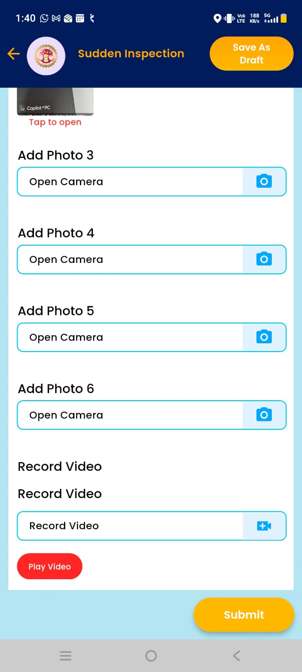
Screen — Sudden Inspection form: Photos 3–6, Record Video, and Submit (bottom section).

4.1.13: Save as Draft — Confirmation
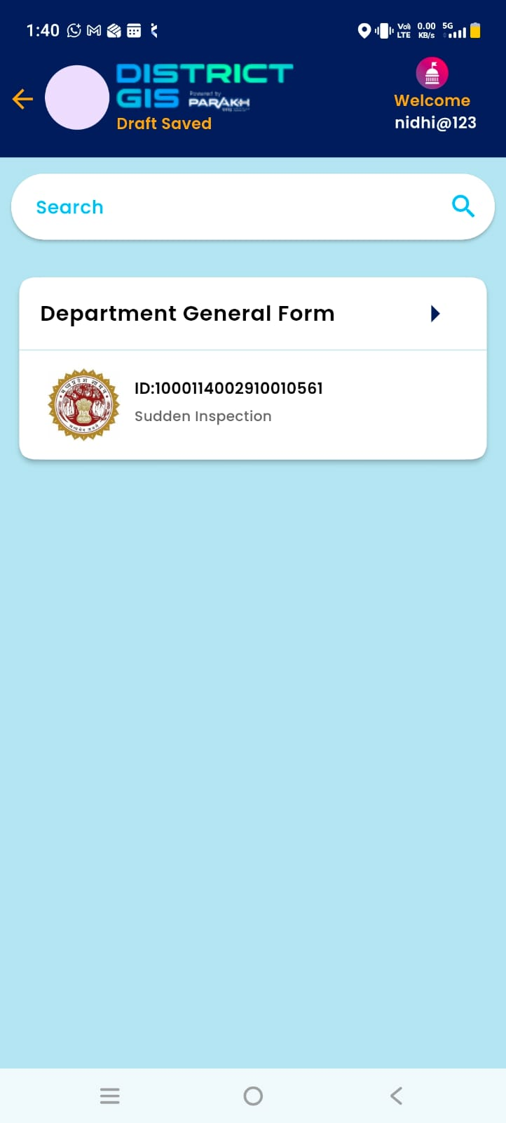
Screen — Draft Saved confirmation, listing the saved Sudden Inspection entry by ID.

4.1.14: Submitted Forms — Confirmation
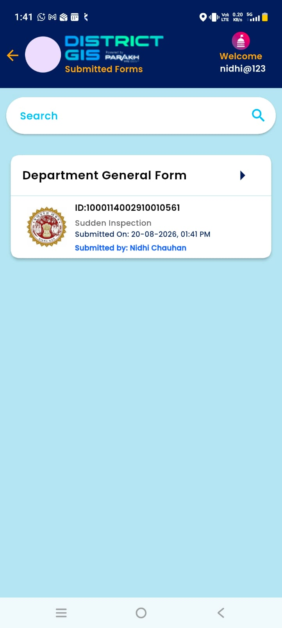
Screen — Submitted Forms confirmation, showing submission date/time and submitted-by user.

5. Web Portal — Sudden Inspection Report
- S.No, Inspecting Officer (name and registered mobile number), Date, District, Entity Type, Inspection Site Name, and Address are shown as core columns.
- Observations captures the inspector's free-text/voice-entered remarks from the mobile form.
- Photo 1, Photo 2, Photo 3… columns each carry a "View" button to open that specific evidence photo (shows "Not Available" if that photo slot was left empty on the mobile form).
- A keyword search box and a From/To date-range filter allow narrowing the list; a refresh icon resets filters.
- "Export to Excel" downloads the filtered result set for offline analysis or reporting.
- Results are paginated (the observed report ran to 27 pages), confirming this report already carries a high submission volume across districts such as Guna and Burhanpur.
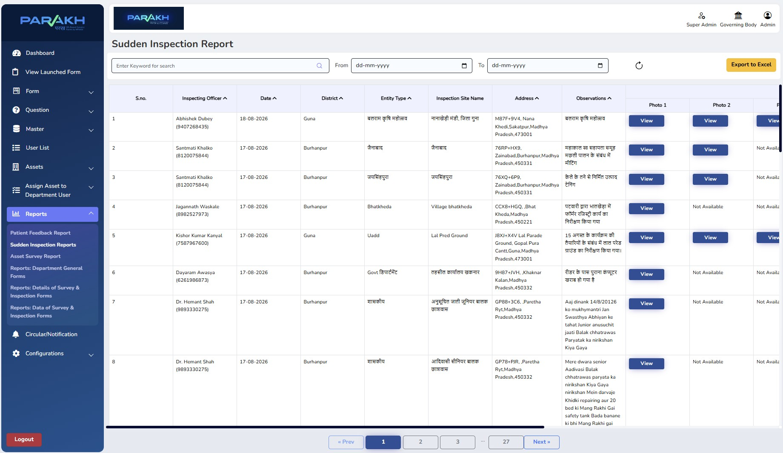
Screen — Web portal: Sudden Inspection Report (Reports → Sudden Inspection Reports), with search, date filters, and Export to Excel.

6. Sign off / Approval
For Department
Name
Approved By
Designation
Organization
Signature with Seal
Date

